**Winter (January) 2022**

Dear Golden Racquets (GR) Members:

Welcome to 2022! I hope all of you entered the new year in good health, and will stay that way! Speaking of good health, it is important for everyone to please not play tennis or pickleball if they are feeling unwell. As we have all heard, the Omicron variant is spreading rapidly and even those of us who are fully vaccinated and boosted can still can get the virus and spread it to others. If any GR members do contract the virus, they are requested to have a negative test result **before** returning to play tennis or pickleball. We are hopeful this latest surge in COVID will end soon.

Tennis cancellations during the week of January 3 due to the unexpected snowstorms are already more of a problem than last year. The Burke Racquet and Swim Club's season is longer than other clubs we use. As a result, there is always overlap between the last days of an ending season and the beginning days of the next season. Making up sessions due to snow cancellations has made this problem worse. We will notify everyone involved in the overlap about his/her specific situation. Our members have been promptly notified of all cancellations thanks to the dedicated efforts of all the club managers and our GR captains. Original weather forecasts for 2022 did not indicate a very snowy winter.

We plan to reopen membership to GR in March 2022, and to begin on court ratings in April 2022. Information on the start of open membership will be emailed to all members and will be provided on the GR web site. There are currently no wait lists for membership being used. Our members continue to be the best recruiters gaining new members.

Stay tuned for information on the summer tennis & pickleball. GR will soon begin planning the 2022 Summer Venue Schedule.

Sincerely,

Tom Burroughs

President, Golden Racquets

~~~~~~~~~~~~~~~~~~~~~~~~~~~~

**Getting to Know Bob Westall**

**by Joe Wittling**



GR member **Bob Westall** was born in Seattle, Washington, on June 8, 1937. He was the 4th son of Joe & Olga Westall. Bob moved from the west coast to the east coast in March 1961 to attend Syracuse University in Syracuse, New York. After graduating with his Bachelor of Science degree in Marketing in 1964, he remained on the east coast of the country.

Bob has been a member of GR since June 2007. In the 14 years of his membership, he has been a venue captain as well as the treasurer of GR. As a venue captain, he led the Monday Fairfax Ladder from September 2008 to May 2017. Bob was also instrumental in making progressive changes to the minimum venue ratings. At one time, the highest rated venue was 3.8, and Bob pushed hard to have the highest rating venue become a 3.9. Now, there are multiple 3.9 rated venues, and they have become the easiest venues to fill with regulars. As treasurer of GR from 2008 to 2015, Bob says he tried hard to bring more "financial control" to GR.

For 42 years, Bob worked in the automobile industry in positions ranging from service and sales manager to distributor field operations manager to general manager. These positions were held at various locations throughout Northern Virginia. Since retiring from the automobile industry, Bob says he spends a great deal of time working on his lawn and garden at his home. He enjoys this very much, but still says his main hobbies are tennis and going to the gym. It became necessary for Bob to undergo hip replacement surgery in April 2021, so his tennis and gym workouts were slowed for a while. However, he is hopeful that he will be able to resume both tennis and his workouts as the new year begins.

Bob has two children but no grandchildren. He enjoys visiting with daughter Christa in South Carolina and with son Jay in North Carolina. Bob also has a dear friend of 40+ years who resides in an assisted living home in Leesburg, Virginia. He calls and chats with this friend several times every day and physically visits the friend twice a week.

Bob says "we are all blessed to have found GR"  and believes it has become the premier senior tennis group in Northern, Virginia.  He credits the time, effort, and behind the scenes work of the many volunteers who fill important positions in the organization that makes this possible. He says the commitment of the volunteers makes it possible for members to "walk onto the tennis court without a care." He encourages members to contact GR President Tom Burroughs and ask him what they can do to help the continued operation of GR.

Joe Wittling says, "Bob taught all of us who were lucky enough to know and play tennis with him, how to be a leader on and off the court. Bob was and is a real leader and a good friend of mine."

~~~~~~~~~~~~~~~~~~~~~~~~~~~~

**What is a Nonagenarian, and Where Can They Found?**

**by Joanne Hensley**

Well, the answer to the first part of that question is that a "nonagenarian" is someone in the age range of 90-99 years of age. And the answer to the second part of the question is that they can be found right here in our very own Golden Racquets organization! So let's meet some

There are a total of 11 members of Golden Racquets -- all men -- who fall into this category, but only three of them are still actively playing tennis or pickleball. There are two additional members -- both female -- who will join the nonagenarian gang in 2022.

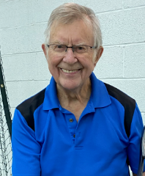

**Frank Roberts** just made the cut by turning 90 in January. He is the only GR member in this group still playing tennis. Frank regularly plays at two GR venues, and anyone who has ever played with him is well aware of his "mean spin" serve and shots. He attributes this to “majoring” in ping-pong during college. Frank is a psychologist who still enjoys working.



Coincidentally, **Bob Dineen** and Frank share the same birthday, with Bob being one year older at 91. Bob developed the software that manages the GR venue assignments and has been an active member of the GR Board of Directors. Prior to his career in the computer world, he was a fighter pilot in the US Air Force, serving two tours of duty in Vietnam. Bob continues to play pickleball in two GR venues, as well as playing in other pickleball locations outside of GR.

**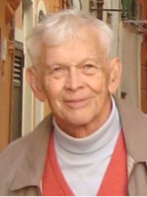**

**Peter Storm**, like Bob, is 91. Peter currently plays at GR pickleball venues but plans to play summer tennis at one of the outdoor venues. He also enjoys spending time on local golf courses and in the gym. Peter attributes his longevity to being a native Norwegian, who seem to live longer. Peter served in the US Army and was stationed in Germany during World War II. His second career took him to the US Congressional Staff of the House Committee on the Budget, from which he retired in 1989.

Other GR nonagenarians are Cap Oliver (who turns 95 on Valentine’s Day), Jack Cogdell, Nelson Castner, Jerry Liess, George Russell, Mark Walicki, Don Calvert, and Jim Lloyd. Alle Cogdel and Jackie Hafner will become GR's only female nonagenarians in 2022. All these GR members are living proof that being involved, maintaining physical movement, and participating in regular exercise are keys to living a long and healthy life. We wish each of them continued good health and longevity!

***"***Aging seems to be the only available way to enjoy a long life!"

***by Daniel F. E. Auber***

~~~~~~~~~~~~~~~~~~~~~~~~~~~

**Helpful Mask Information**

**by Sue Jewett**

**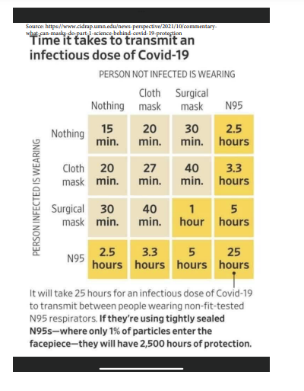**

Many of you may have seen the chart on the right on television or in the newspapers. I found it helpful in understanding the risks of being around people who do not wear masks, and the benefits of wearing the N95 masks.  It compares the effectiveness, measured by the period of exposure, that would be required to become infected while wearing different types of masks.  This chart was published by the University of Minnesota's Center for Infectious Disease Research and Policy. More information on the effectiveness of masks can be found by Goggling the university's Center Infectious Disease Research and Policy. Although GR does not want to get into the mask debate, I wanted to share this information with the GR members so they could be more fully informed, in the event they had not previously seen this chart. I hope you found it useful, interesting, and informative!

~~~~~~~~~~~~~~~~~~~~~~~~

**ANSWERS TO "MEET A MEMBER" CHALLENGE (from previous newsletter)**

In the last issue of the GR newsletter, the following three members were featured in the "Meet A Member Challenge" section. Did you know their names? In the event you did not, here are their identifies revealed -- and if you did, were you correct? Thanks for giving it a-go!

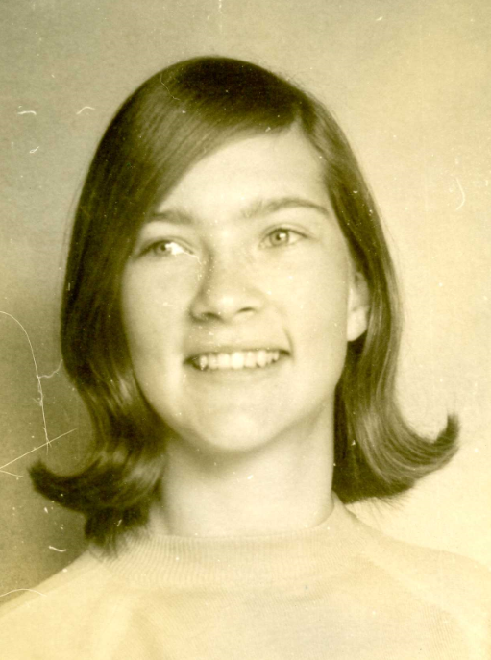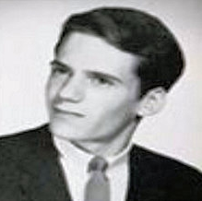

**Maggie Carney Bob Ritter Sue Jewett**

~~~~~~~~~~~~~~~~~~~~~~~~~~~~

**BRAIN BENDERS**

Here are a couple of "head scratchers" that will stretch your brain. Do you know the answers -- look for them in the next edition of the GR newsletter!

* Mr. & Mrs. Mustard have six daughters and each daughter has one brother. How many people are in the Mustard Family?
* A boy was at a carnival and went to a booth where a man said to the boy, "If I write your exact weight on this piece of paper then you have to give me $50.00. But if I do not write your exact weight on the paper, I will give you $50.00. The boy looked around and saw no scale so he agrees, thinking no matter what the man wrote he would just say he weights more or less. In the end, the boy had to give the man $50.00. How did the man win the bet?
* There are only three words in standard English that begin with the letters "dw". Without looking in a dictionary, can you name them?

~~~~~~~~~~~~~~~~~~~~~~~~~~~~

**Please Remember**

* If you or someone you know in GR is feeling under the weather, had an injury or surgery, or lost a loved one, please contact Marion MacRae. Marion will make sure an appropriate card is sent to that person. Please inform Marion by contacting her at 703-751-4994 or at **mmMacrae@comcast.net** when you become aware of someone who could use a "we're thinking of you" card!
* Each member is encouraged to be mindful of their own health and the health of others as you continue to play tennis and/or pickleball indoors, especially with the increased number of COVID cases occurring in Northern Virginia. Remember to follow the guidelines and requirements of each of the clubs at which GR plays regarding their COVID protocols, realizing these protocols may vary from club-to-club. Most importantly, please follow the CDC guidelines for isolation and/or quarantining if you experience symptoms of the virus or test positive for the virus.

~~~~~~~~~~~~~~~~~~~~~~~~~~~~

**Have You Visited the GR Website?**



If the answer to this question is "no," you are encouraged to take a few minutes to visit and browse the GR Website by going to **http://www.GoldenRacquets.org**. You can find lots of information there about membership, coming events, play schedules, GR history, or venues, just to name a few areas of interest. Web master Joanne Hensley updates the website frequently so the information is current, helpful, and user friendly. So take a look and see all the information that is available -- and perhaps even add the website to your "favorites" for easy access!

~~~~~~~~~~~~~~~~~~~~~~~~~~~~

**CHUCKLE CORNER**

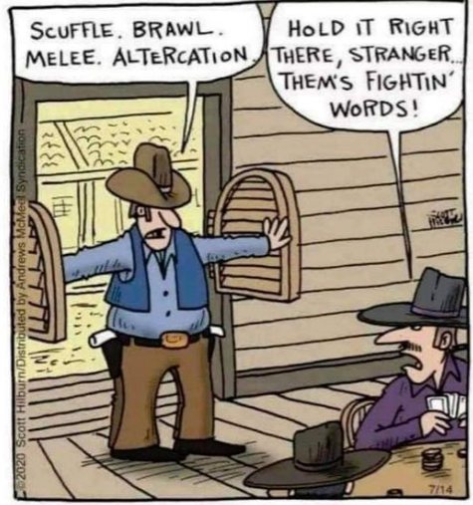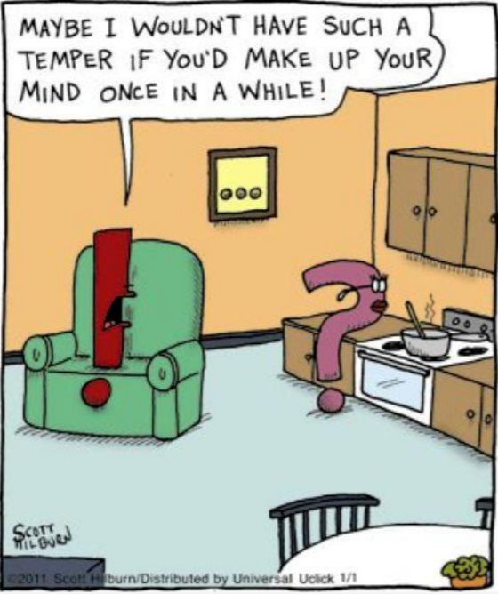

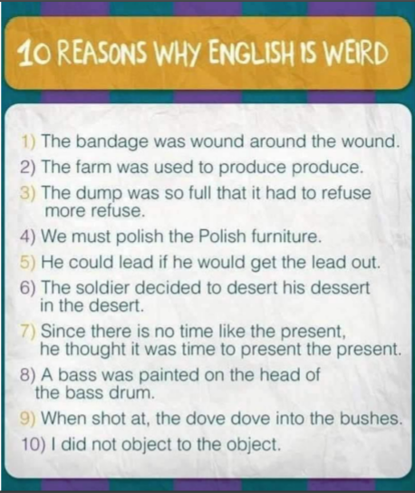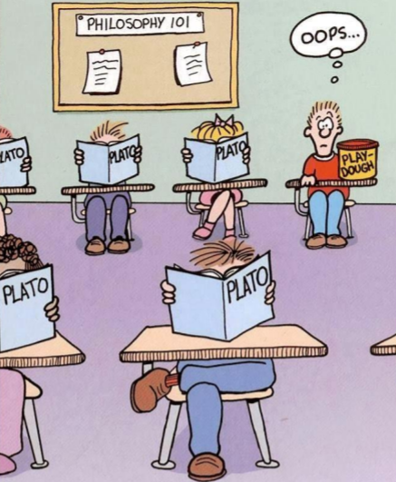

~~~~~~~~~~~~~~~~~~~~~~~~~~~~

|  |
| --- |
| **C:\Users\BobConnie\AppData\Local\Microsoft\Windows\Temporary Internet Files\Content.IE5\Q22JMZQ9\note-34670_1280[1].png**  **Reminder to All**  The GR BOD would like to remind all members that the GR directory is published for the use of members only for contacting other GR members about tennis/pickleball matters. Please note and abide by the disclaimer at the top of the directory, which states the following:  "Golden Racquets publishes this seasonal roster as a service to members who wish to contact other members to pay for substitutions, other reasons related to tennis/pickleball activities, or for personal contact between members. It should **NOT** be used as a mailing or contact source for commercial, religious, political solicitation, or any other purpose." |

**To have an article or picture of interest considered for inclusion in the Golden Racquets Newsletter, please send it to Connie Dineen at:**

[csdineen51@gmail.com](mailto:csDineen51@gmail.com)

NOTE: Articles may be of general interest and do not necessarily need to be about tennis.



**This Golden Racquets Newsletter is published by the Fairfax County Golden Racquets, a non-profit volunteer organization dedicated to senior tennis. You are encouraged to visit the Golden Racquets website at http://www.GoldenRacquets.org. Officers and committee chairs are as follows:**

President: Tom Burroughs

Vice President: Gary Hinson

Special Assistant: Bob Dineen

Recording Secretary: Connie Dineen

Treasurer: Al McFarland

Membership Chair: Adele Neuberg

Rating Committee Chair: Steve Mateo

Social Committee Chair: Vacant

Chief Information Officer: Joe Wittling

Operations & Planning Chair: Dave Fleming

Web Site Manager: Joanne Hensley

Newsletter Editor: Connie Dineen